**Terraform Installation & Script Execution**

Contents

1. Introduction 1

2. Key Features of Terraform 1

a. Infrastructure as Code 1

b. Execution Plans 1

3. Installation of Terraform & running the scripts 1

# Introduction

Terraform is a tool for building, changing, and versioning infrastructure safely and efficiently. Terraform can manage existing and popular service providers as well as custom in-house solutions.

Configuration files describe to Terraform the components needed to run a single application or your entire datacenter. Terraform generates an execution plan describing what it will do to reach the desired state, and then executes it to build the described infrastructure. As the configuration changes, Terraform is able to determine what changed and create incremental execution plans which can be applied.

The infrastructure Terraform can manage includes low-level components such as compute instances, storage, and networking, as well as high-level components such as DNS entries, SaaS features, etc.

# Key Features of Terraform

# Infrastructure as Code

Infrastructure is described using a high-level configuration syntax. This allows a blueprint of your datacenter to be versioned and treated as you would any other code. Additionally, infrastructure can be shared and re-used.

# Execution Plans

Terraform has a "planning" step where it generates an *execution plan*. The execution plan shows what Terraform will do when you call apply. This lets you avoid any surprises when Terraform manipulates infrastructure.

# Installation of Terraform & running the scripts

Build, change, and destroy Google Cloud Platform (GCP) infrastructure using Terraform. Step-by-step, command-line tutorials will walk you through the Terraform basics for the first time.

* 1. Install Terraform

https://learn.hashicorp.com/tutorials/terraform/install-cli?in=terraform/gcp-get-started

* 1. Set up GCP account

https://learn.hashicorp.com/tutorials/terraform/google-cloud-platform-build?in=terraform/gcp-get-started

* 1. Build Infrastructure – Available part of the attached code
  2. Deploy Infrastructure – Available part of the attached code
  3. Create Resource Dependencies – Available part of the attached code
  4. Define Input Variables – Available part of the attached code

The first command to run for a new configuration — or after checking out an existing configuration from version control — is terraform init, which initializes various local settings and data that will be used by subsequent commands.

Initialize your new Terraform configuration by running the terraform init command in the same directory as your main.tf file.

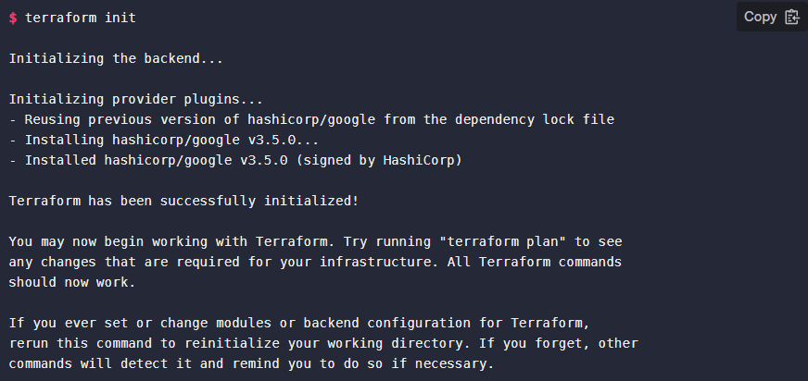

Apply you configuration now by running the command terraform apply

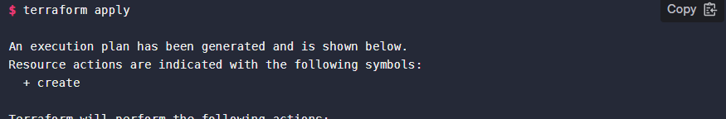

Terraform will indicate what infrastructure changes it plans to make, and wait for your approval before it makes those changes. If the plan was created successfully, Terraform will now pause and wait for approval before proceeding. If anything in the plan seems incorrect or dangerous, it is safe to abort here with no changes made to your infrastructure. In this case the plan looks acceptable, so type yes at the confirmation prompt to proceed.



After this, Terraform is all done! You can go to the GCP console to see the resources you have provisioned. Make sure you're looking at the same region and project that you configured in the provider configuration.

